**CSA4724-DEEP LEARNING FOR NUTRITION ANALYSIS**

**Siddharth d (1922240005)**

**22.06.24 (DAY 2)**

**4.**

**Program:**

import numpy as np

import matplotlib.pyplot as plt

def estimate_coef(x, y):

# number of observations/points

n = np.size(x)

# mean of x and y vector

m_x = np.mean(x)

m_y = np.mean(y)

# calculating cross-deviation and deviation about x

SS_xy = np.sum(y * x) - n * m_y * m_x

SS_xx = np.sum(x * x) - n * m_x * m_x

# calculating regression coefficients

b_1 = SS_xy / SS_xx

b_0 = m_y - b_1 * m_x

return b_0, b_1

def plot_regression_line(x, y, b):

# plotting the actual points as scatter plot

plt.scatter(x, y, color="r", marker="o", s=30)

# predicted response vector

y_pred = b[0] + b[1] * x

# plotting the regression line

plt.plot(x, y_pred, color="b")

# putting labels

plt.xlabel('x')

plt.ylabel('y')

# function to show plot

plt.show()

def main():

# observations / data

x = np.array([0, 1, 2, 3, 4, 5, 6, 7, 8, 9])

y = np.array([1, 3, 2, 5, 7, 8, 8, 9, 10, 12])

# estimating coefficients

b = estimate_coef(x, y)

print(f"Estimated coefficients:\nb_0 = {b[0]} \nb_1 = {b[1]}")

# plotting regression line

plot_regression_line(x, y, b)

if __name__ == "__main__":

main()

**Output:**

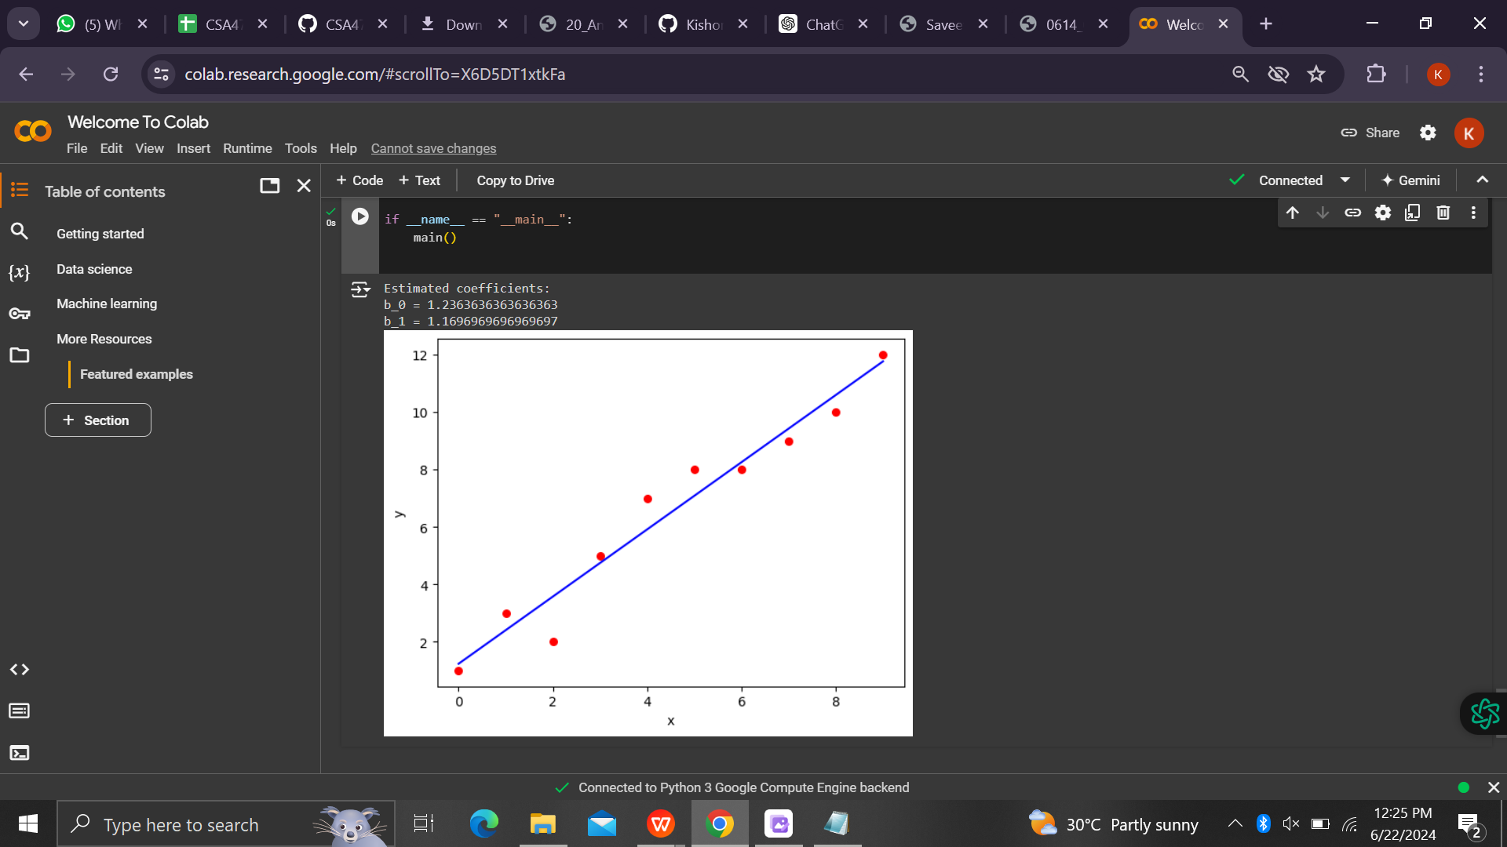

**5**

**Program:**

import numpy as np

import matplotlib.pyplot as plt

def sigmoid(z):

return 1 / (1 + np.exp(-z))

# Define the range for z

z = np.arange(-1, 4, 0.3)

# Calculate the sigmoid values

sigmoid_values = sigmoid(z)

# Plot the sigmoid function

plt.plot(z, sigmoid_values)

plt.title('Visualization of the Sigmoid Function')

plt.xlabel('z')

plt.ylabel('Sigmoid(z)')

plt.grid(True) # Optional: Add a grid for better readability

plt.show()

**Output:**

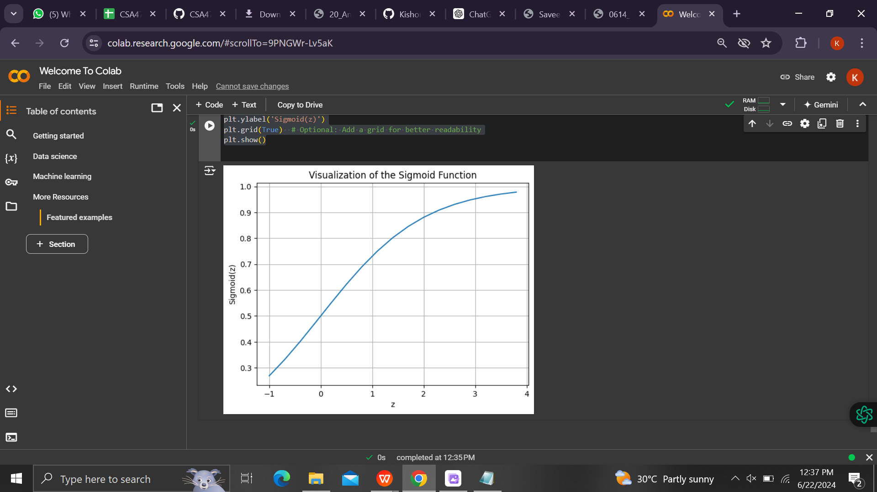

**6(B)**

**Program:**

import numpy as np

import pandas as pd

from sklearn.model_selection import train_test_split

from sklearn.preprocessing import StandardScaler

from sklearn.naive_bayes import GaussianNB

from sklearn.metrics import confusion_matrix, accuracy_score

from sklearn.datasets import load_iris

# Load the Iris dataset

iris = load_iris()

X = iris.data

y = iris.target

feature_names = iris.feature_names

# Checking the dataset structure

print("Dataset shape:", X.shape)

# Splitting the dataset into the Training set and Test set

X_train, X_test, y_train, y_test = train_test_split(X, y, test_size=0.25, random_state=0)

# Feature Scaling

sc = StandardScaler()

X_train = sc.fit_transform(X_train)

X_test = sc.transform(X_test)

# Training the Naive Bayes Classification model on the Training set

classifier = GaussianNB()

classifier.fit(X_train, y_train)

# Predicting the Test set results

y_pred = classifier.predict(X_test)

# Display the results (confusion matrix and accuracy)

cm = confusion_matrix(y_test, y_pred)

print("Confusion Matrix:\n", cm)

accuracy = accuracy_score(y_test, y_pred)

print("Accuracy:", accuracy)

**Output:**

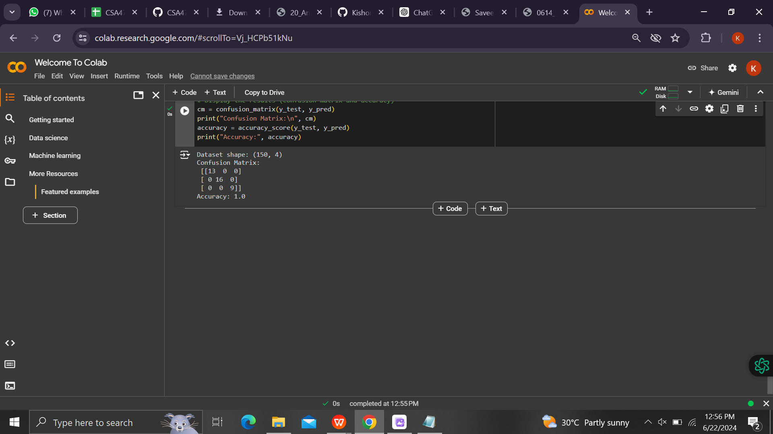

**6(A)**

**Program:**

import numpy as np

import pandas as pd

from sklearn.model_selection import train_test_split

from sklearn.preprocessing import StandardScaler

from sklearn.neighbors import KNeighborsClassifier

from sklearn.metrics import confusion_matrix, accuracy_score

from sklearn.datasets import load_iris

# Load the Iris dataset

iris = load_iris()

X = iris.data

y = iris.target

feature_names = iris.feature_names

# Checking the dataset structure

print("Dataset shape:", X.shape)

# Splitting the dataset into the Training set and Test set

X_train, X_test, y_train, y_test = train_test_split(X, y, test_size=0.20, random_state=42)

# Feature Scaling

sc = StandardScaler()

X_train = sc.fit_transform(X_train)

X_test = sc.transform(X_test)

# Training the K-Nearest Neighbors (K-NN) Classification model on the Training set

classifier = KNeighborsClassifier(n_neighbors=5, metric='minkowski', p=2)

classifier.fit(X_train, y_train)

# Predicting the Test set results

y_pred = classifier.predict(X_test)

# Display the results (confusion matrix and accuracy)

cm = confusion_matrix(y_test, y_pred)

print("Confusion Matrix:\n", cm)

accuracy = accuracy_score(y_test, y_pred)

print("Accuracy:", accuracy)

**Output:**

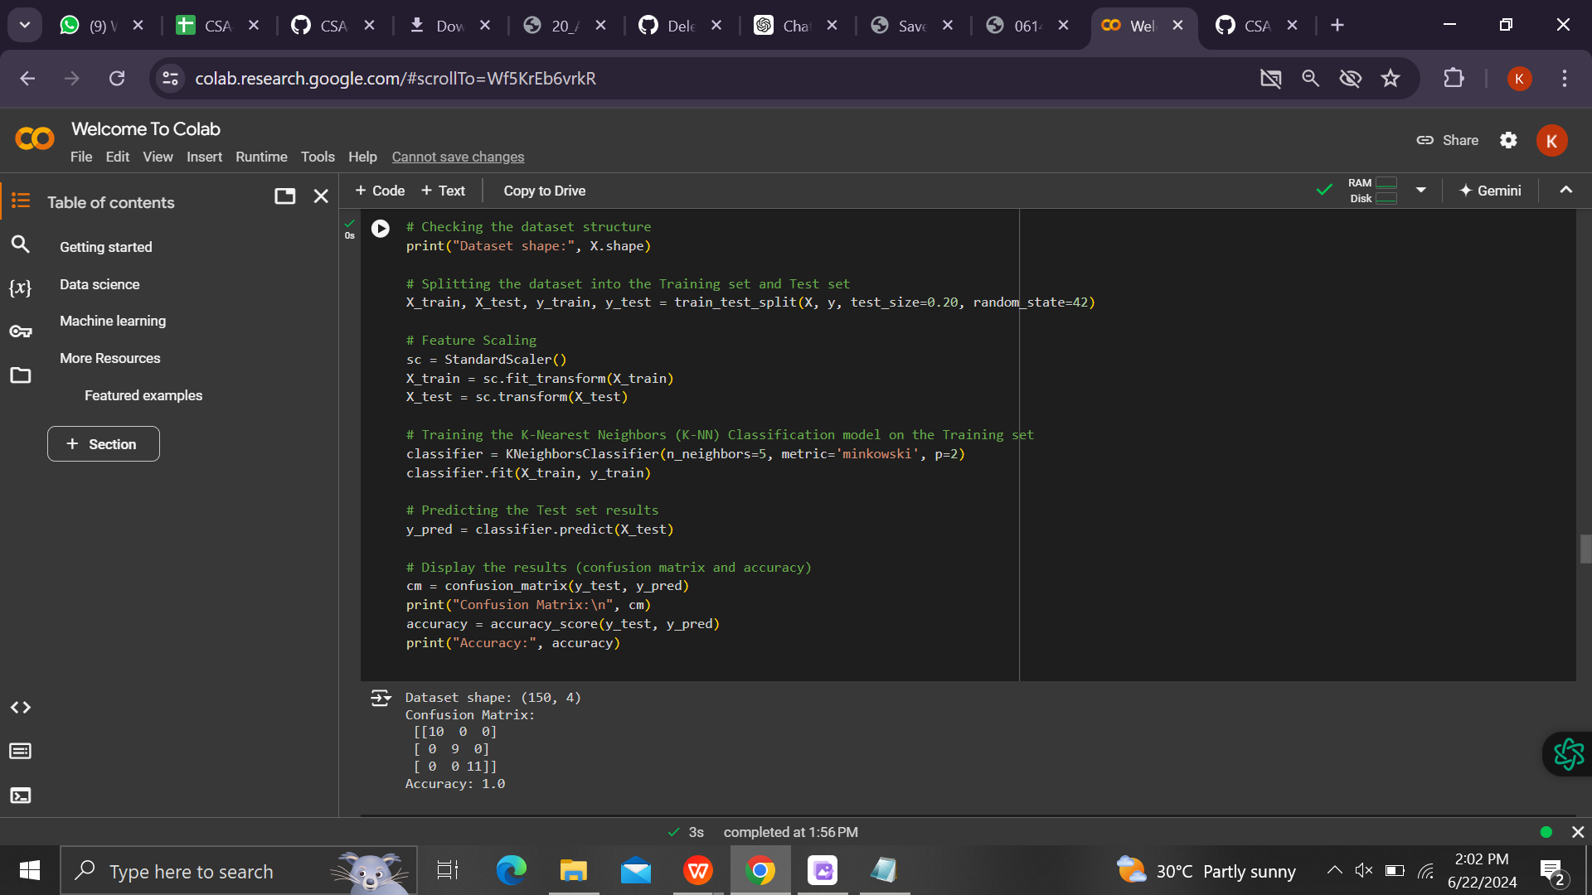

**6(C)**

**Program:**

import numpy as np

import pandas as pd

from sklearn.datasets import load_iris

from sklearn.model_selection import train_test_split

from sklearn.linear_model import LogisticRegression

from sklearn.metrics import confusion_matrix, accuracy_score

# Load the Iris dataset

iris = load_iris()

X = iris.data

y = iris.target

# Splitting the dataset into the Training set and Test set

X_train, X_test, y_train, y_test = train_test_split(X, y, test_size=0.25, random_state=42)

# Training the Logistic Regression model on the Training set

classifier = LogisticRegression(random_state=0)

classifier.fit(X_train, y_train)

# Predicting the Test set results

y_pred = classifier.predict(X_test)

# Evaluating the performance of the model using confusion matrix and accuracy

cm = confusion_matrix(y_test, y_pred)

accuracy = accuracy_score(y_test, y_pred)

print("Confusion Matrix:")

print(cm)

print("\nAccuracy: {:.2f}%".format(accuracy * 100))

**Output:**

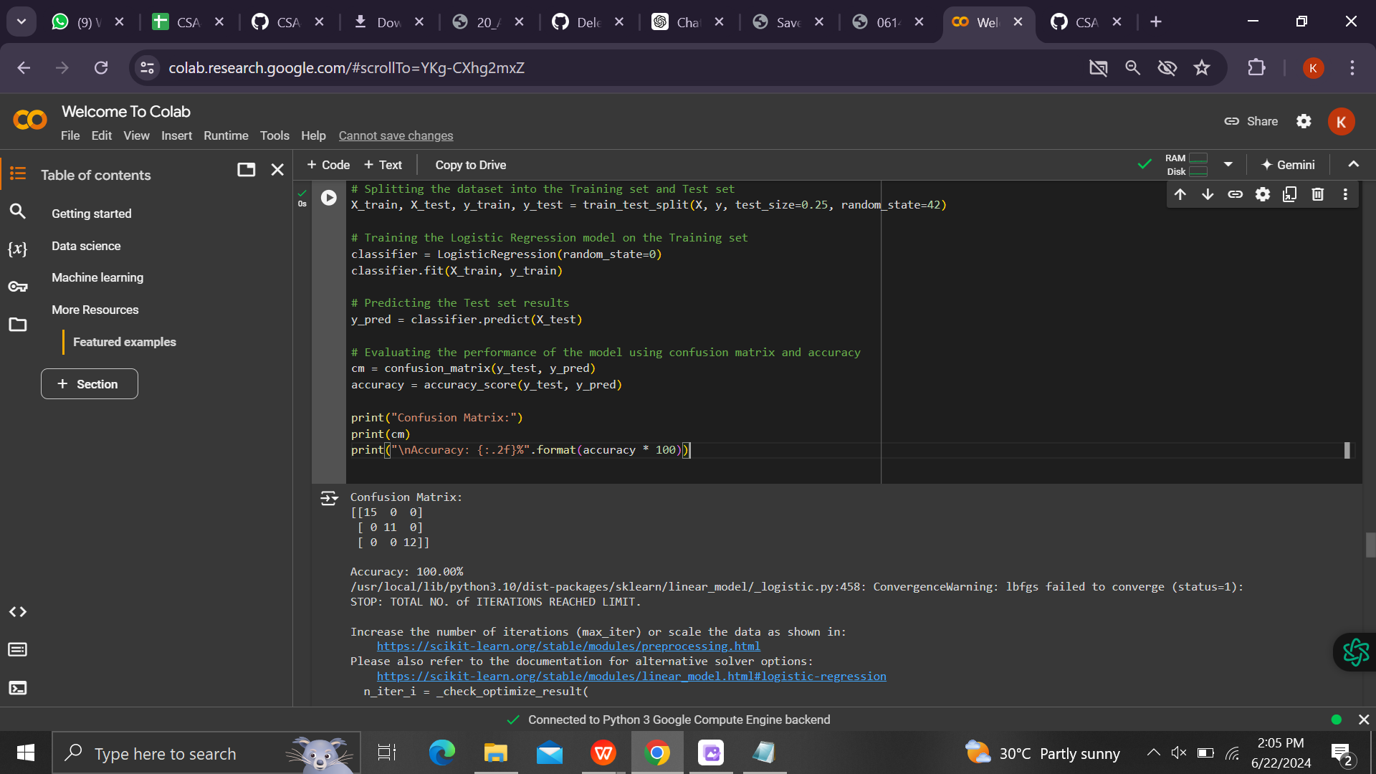

**6(D)**

**Program:**

import numpy as np

import pandas as pd

from sklearn.model_selection import train_test_split

from sklearn.preprocessing import StandardScaler

from sklearn.tree import DecisionTreeClassifier, plot_tree

from sklearn.metrics import confusion_matrix, accuracy_score

import matplotlib.pyplot as plt

from sklearn.datasets import make_classification

# Create a synthetic dataset

X, y = make_classification(n_samples=150, n_features=4, n_informative=3, n_redundant=0, random_state=8, shuffle=True)

# Splitting the dataset into the Training set and Test set

X_train, X_test, y_train, y_test = train_test_split(X, y, test_size=0.20, random_state=7)

# Feature Scaling

sc = StandardScaler()

X_train = sc.fit_transform(X_train)

X_test = sc.transform(X_test)

# Training the Decision Tree Classification model on the Training set

classifier = DecisionTreeClassifier(criterion='entropy', random_state=5)

classifier.fit(X_train, y_train)

# Display the Decision Tree

plt.figure(figsize=(10,10))

plot_tree(classifier, filled=True, rounded=True)

plt.show()

# Predicting the Test set results

y_pred = classifier.predict(X_test)

# Display the results (confusion matrix and accuracy)

cm = confusion_matrix(y_test, y_pred)

print("Confusion Matrix:\n", cm)

print("Accuracy:", accuracy_score(y_test, y_pred))

**Output:**

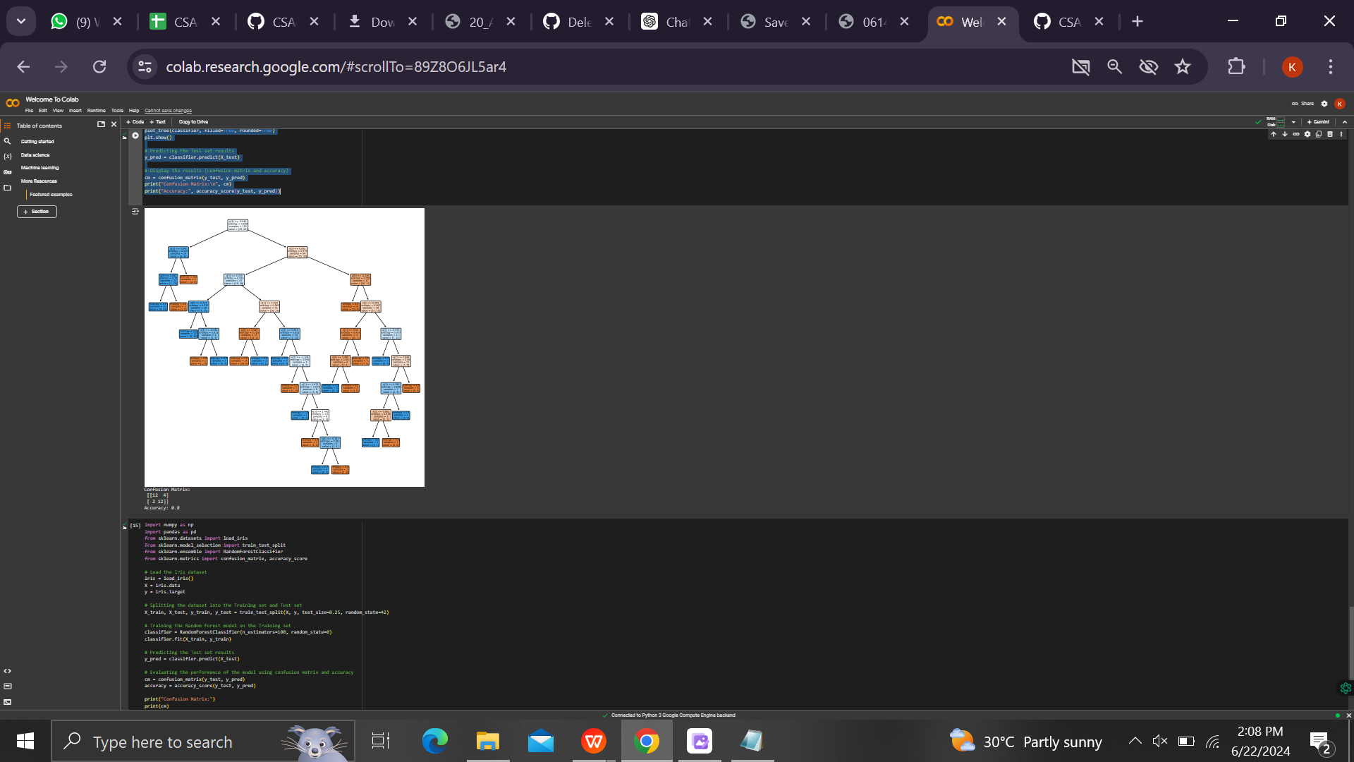

**6(E)**

**Program:**

import numpy as np

import pandas as pd

from sklearn.datasets import load_iris

from sklearn.model_selection import train_test_split

from sklearn.preprocessing import StandardScaler

from sklearn.svm import SVC

from sklearn.metrics import confusion_matrix, accuracy_score

# Load the Iris dataset

iris = load_iris()

X = iris.data

y = iris.target

# Splitting the dataset into the Training set and Test set

X_train, X_test, y_train, y_test = train_test_split(X, y, test_size=0.25, random_state=42)

# Feature Scaling

sc = StandardScaler()

X_train = sc.fit_transform(X_train)

X_test = sc.transform(X_test)

# Training the SVM model on the Training set

classifier = SVC(kernel='linear', random_state=0)

classifier.fit(X_train, y_train)

# Predicting the Test set results

y_pred = classifier.predict(X_test)

# Evaluating the performance of the model using confusion matrix and accuracy

cm = confusion_matrix(y_test, y_pred)

accuracy = accuracy_score(y_test, y_pred)

print("Confusion Matrix:")

print(cm)

print("\nAccuracy: {:.2f}%".format(accuracy * 100))

**Output:**

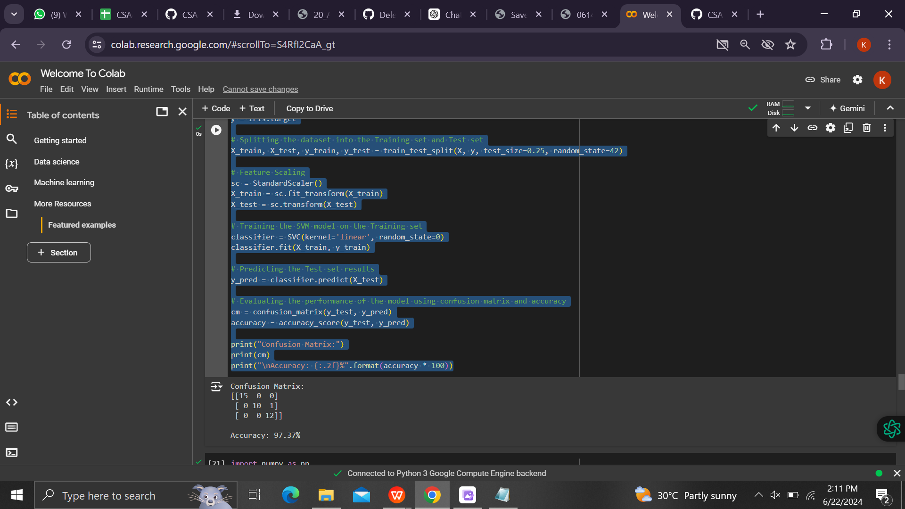

**6(F)**

**Program:**

import numpy as np

import pandas as pd

from sklearn.datasets import load_iris

from sklearn.model_selection import train_test_split

from sklearn.ensemble import RandomForestClassifier

from sklearn.metrics import confusion_matrix, accuracy_score

# Load the Iris dataset

iris = load_iris()

X = iris.data

y = iris.target

# Splitting the dataset into the Training set and Test set

X_train, X_test, y_train, y_test = train_test_split(X, y, test_size=0.25, random_state=42)

# Training the Random Forest model on the Training set

classifier = RandomForestClassifier(n_estimators=100, random_state=0)

classifier.fit(X_train, y_train)

# Predicting the Test set results

y_pred = classifier.predict(X_test)

# Evaluating the performance of the model using confusion matrix and accuracy

cm = confusion_matrix(y_test, y_pred)

accuracy = accuracy_score(y_test, y_pred)

print("Confusion Matrix:")

print(cm)

print("\nAccuracy: {:.2f}%".format(accuracy * 100))

**Output:**

